**Table 1a.** Generalized linear mixed models tested with length of time seedlings were in the ground, fenced or unfenced treatment, and species of seedling as main effects. No interaction between length of time seedlings were in the ground and treatment was the best fit model, and the model without time or interactions between time and treatment was better fit than the full model that included time and interactions.

|  |  |  |  |  |
| --- | --- | --- | --- | --- |
| **Model** | **Number of parameters** | **AICc** | **δAICc** | **Cumulative weights** |
| (Full) Time, species, treatment, treatment:species, treatment:time | 49 | 664.25 | 70.66 | 1 |
| Treatment, time, species, species:treatment | 31 | 593.59* | 0 | 0 |
| Treatment, species, treatment:species | 13 | 612.89 | 19.3 | 1 |

*Best fit model.

**Table 1b.** Generalized linear mixed model results for each of the six species in seedling plots.

|  |  |  |  |  |
| --- | --- | --- | --- | --- |
| **Model** | **Species** | **AICc** | **δAICc** | **AICc weight** |
| With treatment | *Carica papaya* | 121.13 | 0 | 1 |
| No treatment | 155.81 | 34.68 | 0 |
| With treatment | *Morinda citrifolia* | 106.27 | 0 | 0.98 |
| No treatment | 114.55 | 8.27 | 0.02 |
| With treatment | *Premna serratifolia* | 86.4 | 0 | 0.98 |
| No treatment | 94.17 | 7.77 | 0.02 |
| With treatment | *Psychotria mariana* | 78.39 | 0 | 1 |
| No treatment | 100.51 | 22.12 | 0 |
| With treatment | *Aglaia mariannensis* | 79.88 | 0.52 | 1 |
| No treatment | 79.36 | 0 | 0.56 |
| With treatment | *Ochrosia oppositifolia* | 48.94 | 2.72 | 1 |
| No treatment | 46.22 | 0 | 0.8 |

**Table 2.** List and counts of species germinated from deer scats (n=20) and pig scats (n=31). Two native species (highlighted in gray) occurred in large numbers in pig scats, and, except for the fleshy-fruited *Carica papaya*, a small number of non-native species appeared in a few of both pig and deer scats. Species with fleshy fruit and higher numbers of seeds per fruit germinated in higher numbers from pig scats.

|  |  |  |  |  |  |  |  |  |
| --- | --- | --- | --- | --- | --- | --- | --- | --- |
|  |  | **Deer** |  | **Pig** |  | |  | |
| **Species** | **Average seeds per fruit\*** | **No. of scats with this species** | **Average seedlings per scat** | **No. of scats with this species** | | **Average seedlings per scat** | |
| *Morinda citrifolia* | 164 | 0 | 0 | 20 | | 36.10 | |
| *Ficus prolixa* | 189 | 0 | 0 | 3 | | 7.97 | |
| *Carica papaya* | 721 | 1 | 0.05 | 16 | | 8.58 | |
| *Vitex parviflora* | 1-2** | 1 | 0.05 | 0 | | 0.00 | |
| *Passiflora suberosa* | 26 | 1 | 0.4 | 3 | | 0.42 | |
| *Mikania micrantha* | achene | 1 | 0.05 | 0 | | 0.00 | |
| *Coccinia grandis* | 126 | 0 | 0 | 3 | | 0.10 | |
| *Chromolaena odorata* | achene | 0 | 0 | 1 | | 0.03 | |
| *Leucaena leucocephala* | 18** | 0 | 0 | 1 | | 0.03 | |
| unknown |  | 1 | 0.1 | 4 | | 0.26 | |
|  |  |  |  |  | |  | |

Native species shaded in gray.

*Seeds per fruit calculated by hand from fruit collected in the Marianas unless otherwise indicated.

**Seeds per fruit indicated in B. Stone, 1970 [32].

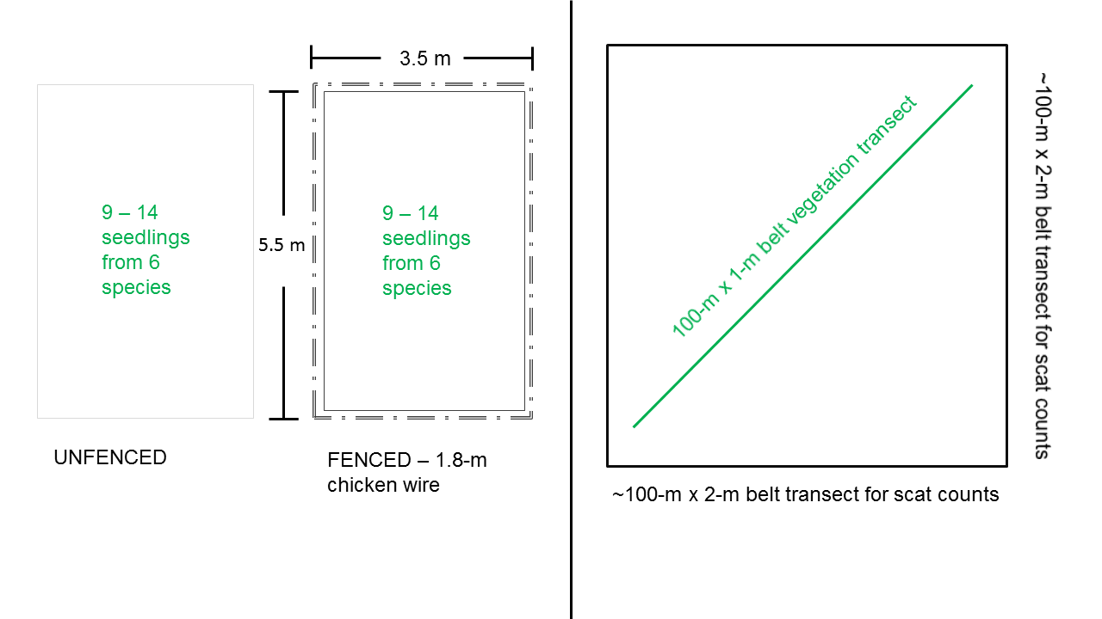

**Figure 1.** Diagram in the left-hand panel shows dimensions for adjacent fenced (no ungulates) and unfenced (ungulates) seedling plots constructed and planted at eight forest sites in Guam. Diagram on the right illustrates the belt transects used to characterize vegetation and the larger belt transect where the surveyor walked the area around the vegetation transect to count scats within a 2-m-width belt as a proxy for ungulate abundance. Transects were conducted at 14 forest sites in Guam.

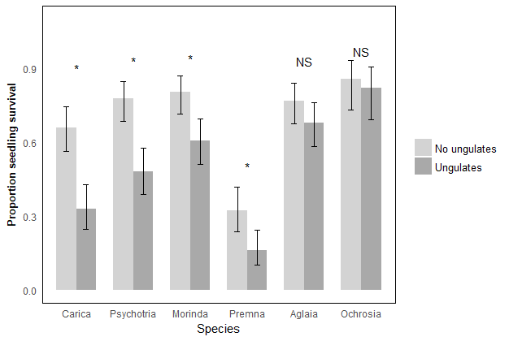

**Figure 2.** A higher proportion of seedlings survived in fenced versus unfenced plots for four out of six forest species. For *Carica papaya*, *Morinda citrifolia*, *Psychotria mariana*, and *Premna obtusifolia*, all indicated with *, the best fit model for proportion alive included treatment, and in all cases, proportion alive inside fenced plots with “no ungulates” was higher than outside fenced plots with “ungulates.” For *Aglaia mariannensis* and *Ochrosia oppositifolia* seedlings, treatment did not contribute to the best fit model explaining proportion of seedlings alive, and proportion of seedlings alive did not differ significantly due to treatment.

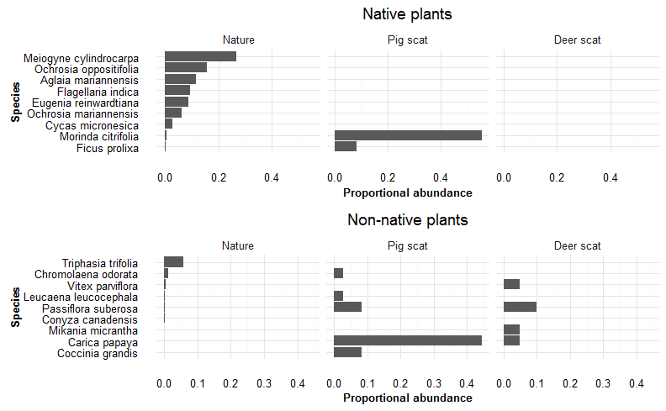

**Figure 3.** Proportional abundances of species in nature, with most abundant at the top, are shown in the left most panel of each bar graph for native and non-native species, in the top and bottom panels, respectively. The top panel shows the most abundant native fruiting species in nature, based on vegetation surveys, with *Meiogyne* *cylindrocarpa* through *Cycas* *micronesica* being the seven most abundant species counted on transects. *Morinda* *citrifolia* and *Ficus* *prolixa*, while not part of the most abundant species on vegetation transects, were two native species that germinated from pig scats in much higher proportions than expected given their abundance in nature. Non-native species, especially *Carica papaya* and *Coccinia grandis*, also germinated in a relatively high proportion of scats, given their relatively low availability in nature. The two right-hand panels show that no native species germinated from deer scats. Instead, a small number of non-native species germinated in just a few deer scats.

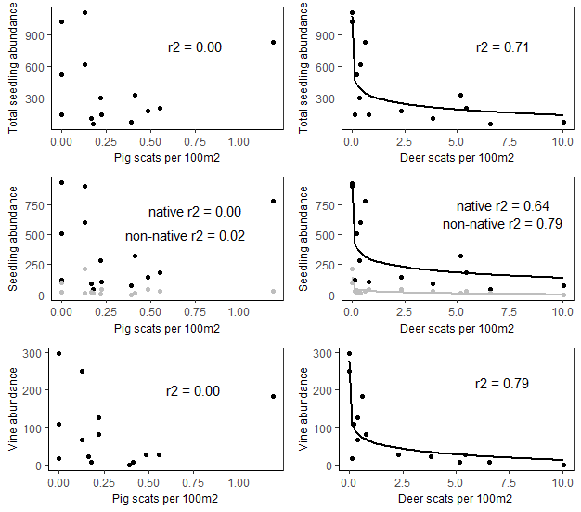

**Figure 4.** In the left-hand column, regression analysis between abundance of pig scats (relative index for population abundance) showed no relationship with total seedling abundance, non-native nor native seedling abundance (middle row, with black line for native and gray line for non-native), nor vine abundance per survey site in Guam. In the right-hand column, abundance of deer scats (relative index for population abundance) show strong negative loglinear relationships to total seedling abundance with r2 values all above 0.6.